# Background

Course: Software Project Development Management

Team: Kuba Haladus, Stephanie Hudon Hagan, John Valin, Kayanne Bryant, Noah Berthusen, Mohona Sengupta

Role: Project Manager / UX Designer

Objectives: Create a startup to deliver a technological product to the city of Leganes, aiming to enhance the infrastructure in some significant way.

Read on to understand the business, or skip to the UX Ideation.

# Developing the Business

All my team started with was a list of possible categories that our product could span. We realized that our business could define itself a **health and welfare** application that would aggregate similar concerns under a single domain. We created ***InteliMed***, a tech firm that would deliver a complete application for city boards to distribute to their citizens.

Of course, my team had to follow the industry standard in Madrid. Rather than using Agile, we were using the **ESA methodology**, a European waterfall-like process that centers around heavy documentation. Out of the twelve documents that we must produce in order to sell our product, I've highlighted the three that I was mainly responsible for as PM and UX Designer.

# Doc Explanation

# Ideation

I found very little time to truly ideate on the design of the application, as most of the semester was focused on the business side of our product. However, eventually it came time to put together a comprehensive front-end to our product.

## Lo Fi Beginnings

We knew which categories we wanted to focus on, but we didn’t know the pain points for the citizens of Leganes until we did our user interviews for the **User Requirements Document.** Those gave us a good idea of what the application would need in order to disrupt the current user journey, and so we came up with a list of features per infrastructure category.

Health Care

* A chat function to immediately speak with a doctor
* Easy access to personal records and medical history
* Information on relevant topics like the dangers of smoking, alcohol, etc.

Public Safety

* A chat function with public officials
* A crime map of local area / analysis of recent crime trends
* Alert system on breaking crime reports

Environment

* Levels of pollution in their neighborhood
* Personal goals (like recycling)

Energy

* Levels of usage in their neighborhood
* Personal goals that they set (turning off the lights, water)

The Household

* A chat function with online therapists
* Easy booking system for appointments with therapists
* Collection of resources like meditation, mental health, etc.

My next problem was deciding the hierarchy of options. If you were a normal person living in Leganes, what would you want to see first? Why are you looking at the app in the first place? My main problem was that I had to step into the mindset of not just a different person, but a different culture. So, I fell back on what I knew: personas.

Personas:

Grandma

Teen

Young mom

Takeaways: My personas help me arrive at a few important insights: **safety** is a big concern, especially in a city. The alert system would be most important to see immediately, so families feel that they know what’s going on in their neighborhood. All the **time-sensitive features**, like daily goals and quick chat options must be easily found. I also realized that **navigation** must be easily understandable and airtight, so every citizen (from an elderly grandma to a teen) could quickly find what they need.

## Wireframing

I finally had an idea of how the information in the application should be organized, so I began sketching out the possibilities.

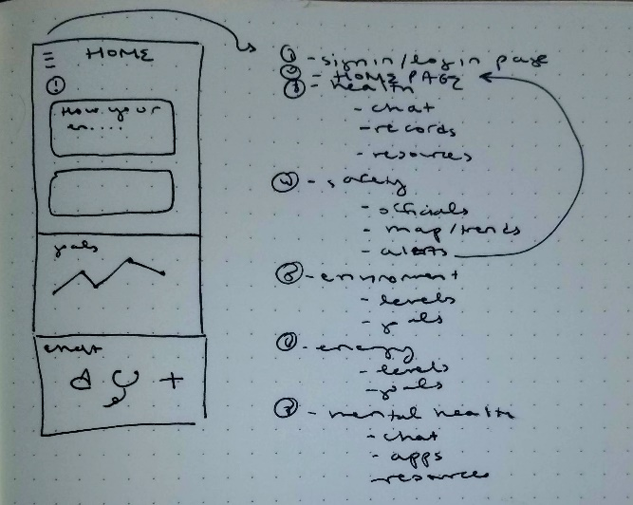

As a team, we decided that the interaction we wanted to showcase most was a user logging in to their home page, swiping away an alert notification, and entering the quick chat feature with a doctor. I tried to iterate through ideas of how to lay out the home page, as it felt like the hardest challenge.

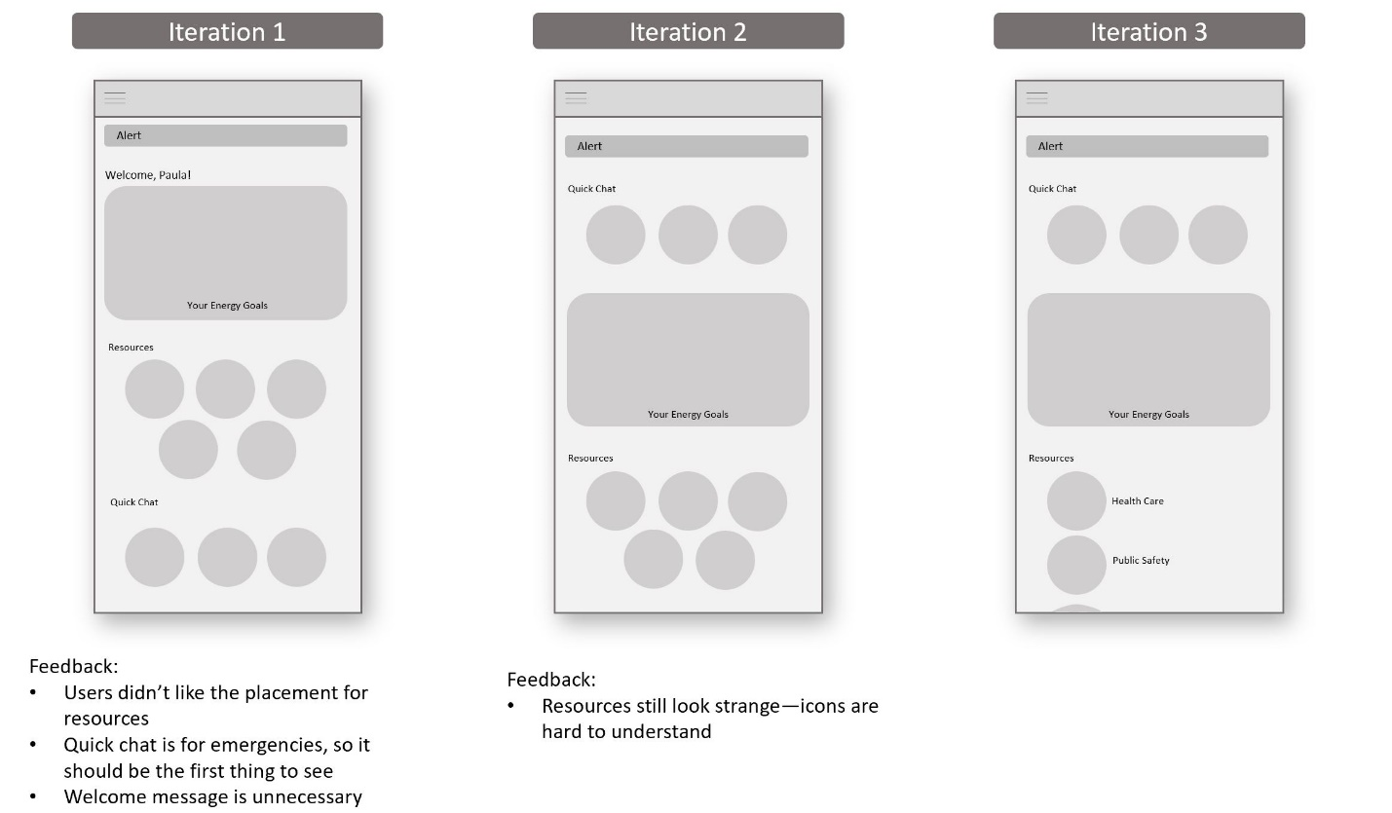

Finally, I was ready to begin work on the high fidelity wireframes.

# Solution

* Easy and clear navigation
* Redundant side menu to really lock in understanding
* First alerts, then emergency chats, then personalized information like goals and finally private info

## Takeaways

This was one of the most difficult projects I’ve produced, and doubly so because I was producing for a userbase that I didn’t quite understand. Study abroad not only brought me a better understanding of Spanish culture, but of the European business standard. The UX was honestly the easiest part—being a PM was tougher than I ever imagined. This was my first experience with budgeting for business, with directing a team, and making sure we not just delivered on time but on quality as well. At the end of the semester, not only was I incredibly proud of the product, but I was incredibly proud of my team as well.

# ~~An Intro~~

~~I never expected to be trying to build a fake startup in Europe, but somehow life finds a way. In the spring of 2019, I studied abroad in Madrid, Spain. While my fun reasons for studying abroad are never ending, I did have one practical reason. There was a class that I wanted to take at the Universidad de Carlos III called~~ *~~Software Project Development Management~~*~~. The class was centered around creating a Smart City product for the city of Leganes, from the initial sale to architectural and system design to the final pitch.~~

~~I worked with a group of six people to create a product~~ ~~centered around health for the citizens of Leganes. We wanted to plan out a connected infrastructure to improve on health care, public safety, environmental issues, energy usage, and the community and household. Over the course of four months, we published twelve documents outlining all of our business decisions.~~

~~One of the most interesting parts of the class was learning about the European business standard. Rather than using Agile, we were using the ESA methodology, an European waterfall-like process that centers around heavy documentation. All twelve documents had to be meticulously planned and detailed, with quality assurance taking place on each to ensure the same look and “brand” feel. It’s something I’ve never done before, and I had an absolute blast.~~

# ~~Project Introduction~~

~~Course: Software Project Development Management~~

~~Team: Kuba Haladus, Stephanie Hudon Hagan, John Valin, Kayanne Bryant, Noah Berthusen, Mohona Sengupta~~

~~Role: Project Manager / UX Designer~~

~~Objectives: Create a business and deliver a holistic product to the city of Leganes, aiming to enhance the infrastructure in a significant technological way.~~

~~I never expected to be trying to build a startup in Madrid, but somehow life finds a way. In the spring of 2019, I studied abroad at the Universidad de Carlos III. One of my courses was SPDM, a class designed to be the capstone of their Management Information Systems program.~~

~~Our project was to not only create a business, but also deliver a software that must improve the infrastructure of our local city, Leganes. My group created~~ *~~InteliMed,~~* ~~a business that would deliver a welfare product centered around health care, public safety, environmental issues, energy usage, and the community and household.~~

~~Over the course of four months, we published twelve documents outlining all of our business and software decisions, and final application wireframes. I served as Project Manager during the semester for the six person team~~*~~,~~* ~~as well as delivering the final design for the application as the UX Designer.~~

# ~~SPO~~

~~Our mission as a business was to provide a product for the citizens of Leganes that would make them feel safe and cared for, to provide them with the means of connection with the right resources, and to give them the ability to protect their environment. We decided on a user friendly and simple mobile application with these main features:~~

* ~~Ability to access personal medical records and family history, a chat function with doctors, and information about local hospitals and pharmacies~~
* ~~Neighborhood alerts for crime and natural disasters and the ability to reach out to public officials~~
* ~~Ability to track pollution in the neighborhood, and raise environmental awareness~~
* ~~Ability to track personal energy usage and set goals for each household~~
* ~~Resources on mental health and easy communication with therapists~~

~~We also created a Gannt chart to visualize our deliverable schedule, and an overall budget to provide a accurate cost analysis for our “clients”, the city of Leganes. You can see the entire document here.~~

# ~~URD~~

~~This document helped us explicitly define each user requirement we would offer our client and how they would look. Interviewing the local citizens was a bit of a challenge as it was in entirely in Spanish, but we were able to take away some key insights:~~

* ~~The mobile application must be easy to use for the full spectrum of citizens, from the elderly to the young. In short: organized, informal, and visual.~~
* ~~Spaniards valued the face-to-face interaction they received at the local pharmacies, so our application had to mirror that friendliness.~~
* ~~Data and the analysis of data would be incredibly interesting to many citizens: crime trends, environmental data, and energy usage in specific.~~

# ~~PHD~~

~~This was our final document for the project and to our clients. We had only two slight deviations from our Gannt chart, and even delivered under budget! Our document, budget, and final wireframes were scrutinized by a panel of professors, and we passed with flying colors. After our ideation and research, our application offered the:~~

## ~~Ideation~~

~~My goal in the ideation of the final wireframes was to not just include all the functionality, but to present it in a easy and organized way.~~